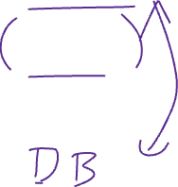

1. Create a github repo
2. Setup project
3. FE + BE

FE:

* DOM & DOM manipulation
* HTML + CSS
* CSS Box model + Flexbox <https://css-tricks.com/snippets/css/a-guide-to-flexbox/>

BE:

* Java + Javalin web server
* Client-server architecture
* Serve static files
* Template engine: Thymeleaf
* JDBC